|  |
| --- |
|  |
| COMPUTER ORGANIZATION |
| Lab Report |
| **Course Instructor:** SIR JEHANZEB  **Lab Engineer:** Lab Engineer RIMSHA TARIQ  **Student Name:** HINA HAQ  **Registration Number:** 343968  **Degree/ Syndicate:** CE 42 A |

DATE:

6,05, 2021

**1. Assume the following data declarations**

**num1: .word 651**

**num2: .word 42**

**ans1: .word 0**

**Perform the following operation, get the result in a register and then storing the register back to the memory.**

**ans1 = num1 + num2**

**CODE:**

.data

num1: .word 651

num2: .word 42

ans1: .word 0

.text

.globl main

main:

li $s0, 0x1001000

lw $t0, 0($s0)

lw $t1, 4($s0)

lw $s1, 8($s0)

add $s1, $t0, $t1

sw $s0, 8($s0)

li $v0, 10

syscall

**screenshot:**

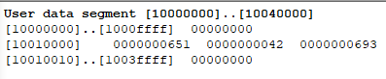

**2. Write the assembly for the following statement:**

**Arr[6]= 2*I + 7 +9(arr[4]), for I = 7**

**EXP. Ans = 2*(7) + 7 + 9*(55) = 516**

**CODE:**

.data

arr: .word 11 22 33 44 55 66 77

.text

.globl main

main:

li $s0, 0x10010000 #Loads base address of array into $s0

lw $t0, 16($s0) #Loads 5th element of the array

li $t1, 7 #Loads the value of I

li $t2, 9

li $t3, 2

mul $t0, $t0, $t2 #multiplies arr[4] with 9

mul $t1, $t1, $t3 #multiplies I with 2

add $s1, $t0, $t1

addi $s1, $s1, 7

sw $s1, 24($s0) #stores final result at arr[6]

**SCREENSHOTS:**

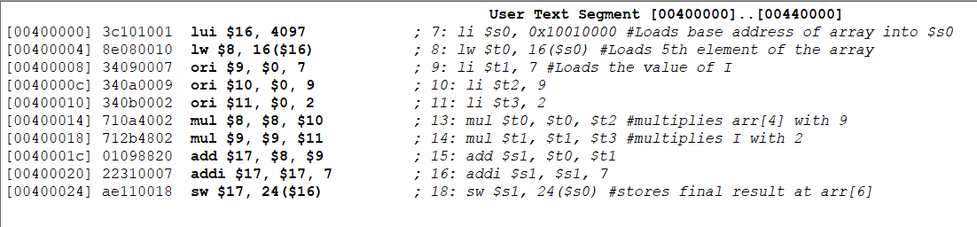

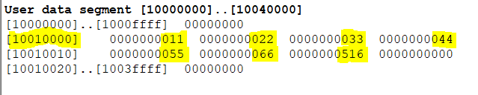

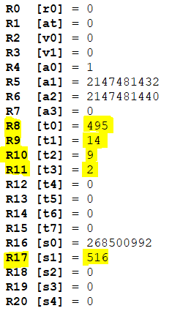

**3. What is difference between load word and store word?**

Store word(sw) is an instruction command used to copy data or value from memory to the register. It is of 4 bytes while load word(lw) is the opposite of store word and does exactly opposite of store word, it is an instruction command used to copy data or value from register back to the memory, it is also of 4 bytes.

**4. Describe briefly how the destination memory address is calculated in a store word instruction?**

Calculation of the destination memory address in a store word instruction has the same procedure as the source address has in load word instruction. It is calculated either by giving offset to the base address of an array or the second way is to directly using the variable name declared earlier in the data segment.